Claude Code Terminal Instruction:

Read CLAUDE.md. This is the ExecEdgePro website project.
Director Mara to open Session 1.
Objective: audit the existing execedgepro.com website.
Fetch the live site and tell me in plain English:
1. What pages currently exist
2. What's working well
3. What's missing or broken
4. What the top 3 priority improvements are
Do not write any code yet — exploration phase only.

, Okay, so this is just to continue with the recording session. Right now we are on reses. we need to return by six fifty PM tonight and given that one we need to take some rest and hopefully gain some more energy as we return to the session at 6th and Tuesday PM tonight.

That's it.

Okay, so just to segment the feature of Elite Right App, we are opening it right now and try to record a few more in the audio recording so that we can assimilate how the elite right model feature response and at this point in time, we are just waiting for the return of the flow and track.

So, supposedly, we are to get some feedback on this feature of EliteWrite applications. So, let's try to stop this for now and take a look if there is a a record already on the modern feature.

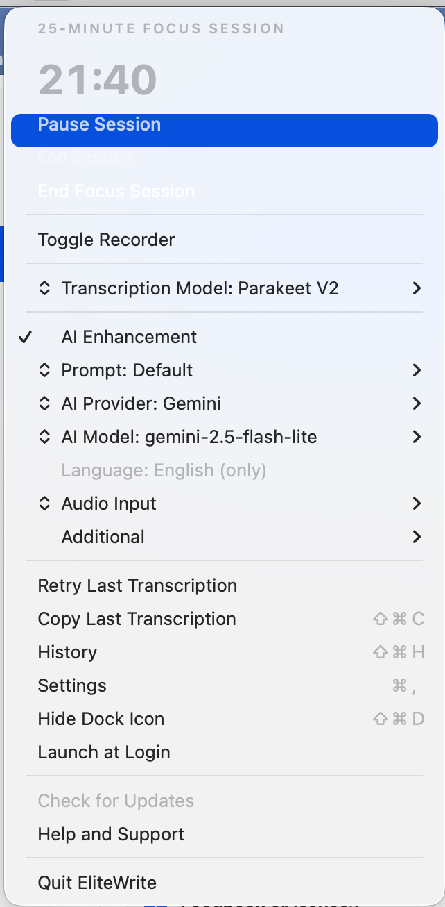

=== ELITEWRITE SYSTEM INFORMATION ===
Generated: May 21, 2026 at 5:44:44 PM

APP INFORMATION:
App Version: 1.0
Build Version: 1
License Status: Not Licensed

OPERATING SYSTEM:
macOS Version: Version 26.5 (Build 25F71)

HARDWARE INFORMATION:
Device Model: MacBookAir10,1
CPU: Apple M1
Memory: 8 GB
Architecture: Apple Silicon (ARM64)

AUDIO SETTINGS:
Input Mode: System Default
Current Audio Device: MacBook Air Microphone
Available Audio Devices: iPhone Sierra Microphone, MacBook Air Microphone, Microsoft Teams Audio, ZoomAudioDevice

HOTKEY SETTINGS:
Primary Shortcut: Right ⌘
Secondary Shortcut:
Middle-Click Recording: false
Middle-Click Activation Delay: 200 ms

TRANSCRIPTION SETTINGS:
Selected Model: Parakeet V2
Selected Language: en
AI Enhancement: Enabled
AI Provider: None selected
AI Model: None selected

UI SETTINGS:
Hide Dock Icon: false
Recorder Style: mini

RECORDING FEEDBACK:
Sound Feedback: true
Pause Media While Recording: false
Mute Audio While Recording: true
Audio Resumption Delay: 0.0s

CLIPBOARD & PASTE SETTINGS:
Restore Clipboard After Paste: true
Clipboard Restore Delay: 2.0s
Use AppleScript Paste: false

POWER MODE:
Power Mode Enabled: false
Persist Configured Preferences: false

DATA CLEANUP SETTINGS:
Auto-Delete Transcriptions: false
Transcription Retention: 1440 minutes
Auto-Delete Audio Files: false
Audio Retention Period: 7 days

PERMISSIONS:
Accessibility: Granted
Screen Recording: Granted
Microphone: Granted

Okay, so this is a short recording on the panel. Oh okay, so this is a child check on the PTT the CK.

My thoughts on the user-feel of the EW app:
- Okay, so number one, we need a description on the background of how each item in the dashboard functions. This is probably where a Release Note File comes in handy.

- So, like for example, in the in the dashboard, what is the goal of the dashboard? And the next one to that is what is the function of the Focus Session, how is the Focus timer intertwines with the audio recording?

- I need definitions of what's in each individual component of the EliteWrite menu. Maybe a brief context statement found anywhere – maybe on top of the each window once it opens gives a user-friendly vibe to the system.

- When you open an app where you transcribe the text, like if you open Microsoft Word and you started recording there. When you try to check on other components, other apps, and even just opening EliteWrite app to see the score, the progress, you lose the text from the entire transcription – as in you won’t see anything on the Word file, after closing the recording with the CK button. You lose the transcription on where you started, in this case, the Microsoft Word. You will only see the entirety of the recording at the EliteWrite history file. You need to make note of that.

Hello Claude, I was hit with my session limit before CC could process the above command. Anyway, while waiting for the session reset, I went through the actual use of the app. I have updated a text entitled EW Actual Use Feedback to the Files. Please go over it and do include in the above statement to tell to CC.

